For Snapshotting a VM

Go to the website <https://cclvc01/>

Choose the “vSphere Client (HTML5)” option

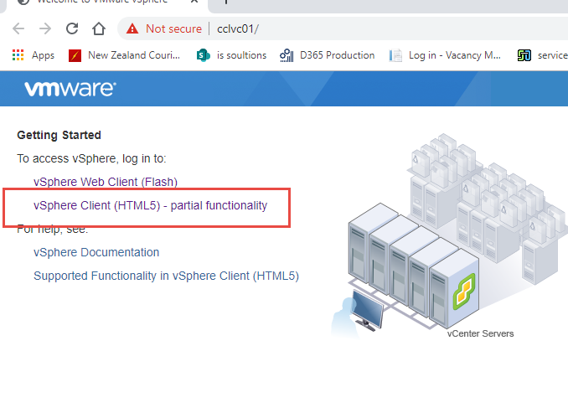

Log in with your admin credentials

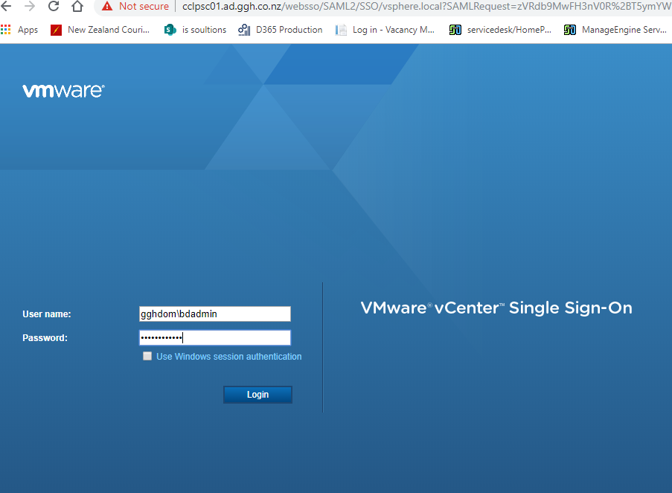

Search the VM you want to snapshot and select it

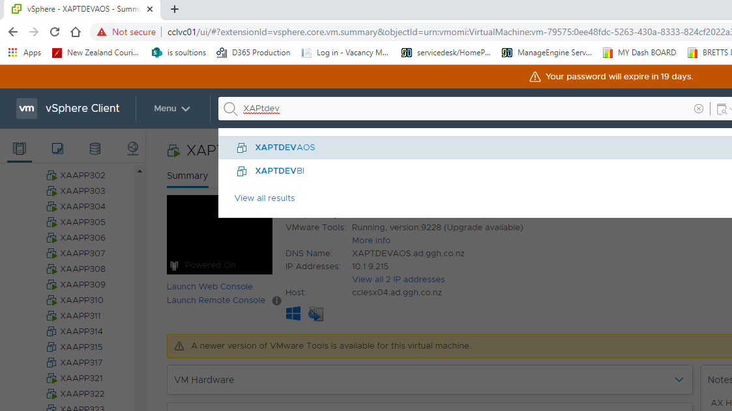

To take a snapshot click “Actions” > “Snapshots” > “Take Snapshot”

